
HASS  Australia in the past |  | Year 6 |  |  | Unit 1
Assessment task — Australia in the past
Name |  |  | Class
Teacher |  |  | Date

Task
Purpose of assessment: To explain the significance of key people, events, institutions and processes to the development of the Australian nation.
Part A: Examining key figures, events and ideas that led to Federation
Students will:
- Sequence information about events and the lives of individuals in chronological order.
- Recognise the contribution of individuals and groups to the development of Australian society since Federation.
- Describe the cause and effect of events on society.
- Locate and collect useful data and information from primary and secondary sources.
- Examine the key figures, events and ideas that led to Australia’s Federation and Constitution.
Part B: Investigating democratic Australia
Students will:
- Generate alternative responses to an issue, using criteria to make decisions and judgments and consider advantages and disadvantages of preferring one decision over another.
- Investigate the key institutions, people and processes of Australia’s democratic and legal system.
- Present ideas, findings, viewpoints and conclusions in a range of communication forms that incorporate source materials.
- Reflect on learning to propose personal and/or collective action in response to an issue or challenge, and predict the probable effects.
Part A: Examining key figures, events and ideas that led to Federation
- Sequence three key events in the life of Sir Henry Parkes in chronological order.
Year | Event
- List the social, political and/or economic effects of the Tenterfield Oration.
- inspired people to dream

- Generate additional criteria to assess the issue — Should ‘Father of Federation Day’ be introduced to recognise the achievements of Sir Henry Parkes?
I want a day that honours the achievements of Sir Henry Parkes.
I will call it the Father of Federation Day Bill.
Use tally marks to reflect each group member’s point of view for each criterion.
Criteria | Agree | Neutral | Disagree
Sir Henry Parkes was a motivational leader. | II | I | I
Not everyone deserves a day of celebration.
Henry Parkes deserves the title ‘Father of Federation.’
Write an argument to support your point of view on the Father of Federation Day Bill. Use sources to justify your argument.

Topic sentence (what is this argument about?)
Are Sir Henry Parkes’ achievements significant enough to support this Bill?
How have Parkes’ actions changed Australia in the past and present?
Explain using specific events and details.
Elaborate using evidence from sources (primary and secondary).
Link the person, group or event to the historical significance (past and present).
- Identify the sources you have used in your argument. An example has been provided.
Burrows, N. (1899) ‘Little Nation’, The South Australian Chronicle, Adelaide
Part B: Investigating democratic Australia

Your task
Ministers introduce Bills into parliament. These are often issues raised by citizens.
Identify a day of recognition that you think is important enough for a public holiday, and
present the case to introduce a Bill to parliament.
In your group you will:
- identify possible days of recognition and identify their purpose
- use criteria to choose one day
- develop arguments to justify your decision
- present your idea and viewpoints.
- Identify and explain days of recognition that could be raised in each type of Parliament. Use initials to identify each person’s idea.
National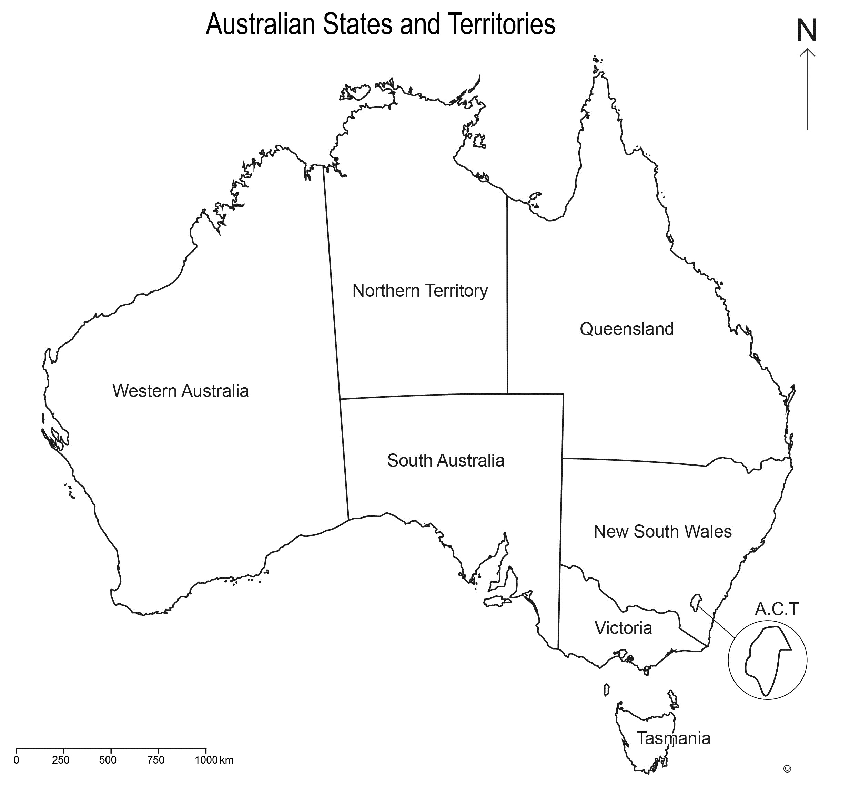 | - ‘Father of Federation’ day – in recognition of Henry Parkes’ achievements in establishing democracy.
State
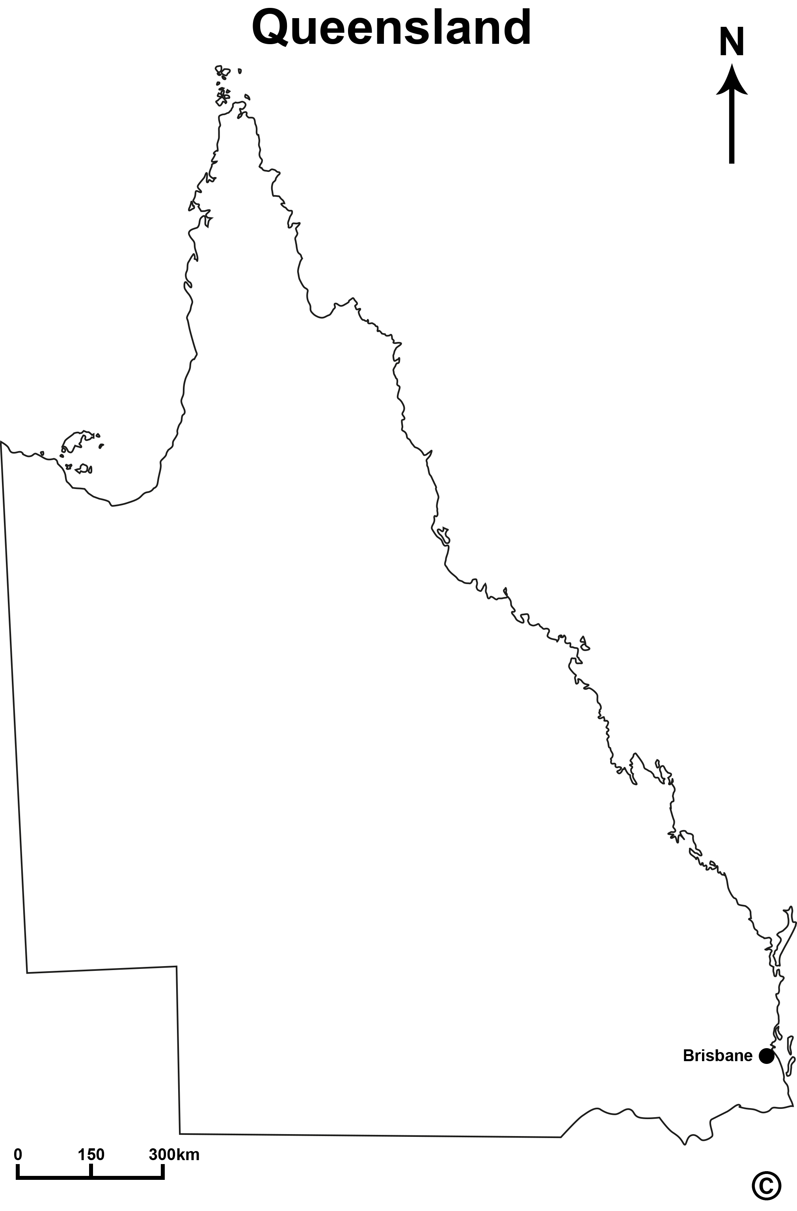
Local
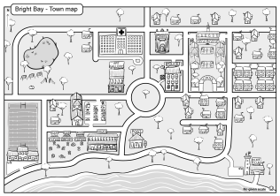
- Use the criteria below to help your group decide on your new public holiday.
Criteria | Supporting questions
Significance | How does this day support Australia’s past, present and/or future?
Continuity | How relevant will this day be in the future?  How will it celebrate or commemorate consistently in the future?
Cause and effect | Is the decision ethical, fair and safe?  What are the potential economic, social or environmental effects?

- Identify your chosen day and the level of parliament where your idea would be raised. Explain why your group chose this issue.
Write this part on your own. Use the criteria in your response.
- Identify arguments for and against this day of recognition.
For | Against
- Present your issue. Make sure you address the following:
- What is the Bill you are presenting?
- At which level of Parliament would it be raised? Who might raise it?
- How does the day meet the criteria?
- What are your arguments for and against the issue? Who would argue each point?
- What are the probable effects of this Bill?
- What sources were used to understand or support your decision?
- Explain roles and processes within Australian parliament and how they support the democratic and legal systems.

Year 6 HASS: Unit 1 — Australia in the past | Name:
Purpose of assessment: To explain the significance of key people, events, institutions and processes to the development of the Australian nation.
Knowledge and understanding |  |  | Questioning and researching |  |  |  |  | Analysing and interpreting |  |  |  | Communicating
Explain the significance of an event/ development, an individual.  Describe the causes and effects of change on society.  Explain the importance of people, institutions and processes to Australia’s democracy and legal system. |  |  | Locate and collect useful data and information from primary and secondary sources.  Sequence information about events, the lives of individuals in chronological order. |  |  |  |  | Collaboratively generate alternative responses to an issue, use criteria to make decisions and identify the advantages and disadvantages of preferring one decision over others.  Reflect on learning to propose personal and/or collective action in response to an issue, and predict the probable effects. |  |  |  | Present ideas, viewpoints and conclusions that incorporate source materials, communication conventions and discipline-specific terms.
 |  | Evaluates significance of Sir Henry Parkes’ actions.  Makes explicit connections between significant events, individuals and Australia’s democratic processes. |  |  |  | Uses chronological evidence to support argument. |  |  |  | Evaluates multiple social, economic and environmental factors and potential effects when proposing an idea. |  |  |  | Manipulates evidence, historical terms and language features to persuade.  Articulates a range of well-reasoned ideas and perspectives within a proposal. | A
 |  | Elaborates on the effects of change.  Makes connections between parliament and laws. |  |  |  | Uses and acknowledges multiple sources to support ideas. |  |  |  | Generates criteria.  Assesses the possible effects of decisions. |  |  |  | Elaborates using source evidence.  Justifies reasoning using multiple criteria. | B
 |  | Explains the significance of Sir Henry Parkes’ actions.  Describes cause and effects.  Explains the importance of people and processes to Australia’s democracy and legal system. |  |  |  | Locates useful information from sources.  Sequences events in the life of Henry Parkes in chronological order. |  |  |  | Generates alternative responses.  Uses criteria to make a decision.  Identifies advantages or disadvantages of decision.  Reflects on learning to propose action. |  |  |  | Presents an argument that incorporates historical terms and source information.  Presents viewpoints and conclusions to peers. | C
 |  | Identifies significant actions or events and an effect. |  |  |  | Records data.  Sequences events. |  |  |  | Generates a response to an issue.  Makes a decision. |  |  |  | Communicates an opinion.  Presents a Bill. | D
 |  | Identifies an action, event or effect. |  |  |  | Lists events and/or years. |  |  |  | Acknowledges a response. |  |  |  | Lists ideas. | E

Feedback:

